Chlorpyrifos
221

HPLC method

CIPAC Full Scale Collaborative Trial

Shenyang SYRICIT Testing Co. Ltd.

CHLORPYRIFOS
221

ISO common name Chlorpyrifos

Chemical name O,O-diethyl O-3,5,6-trichloro-2-pyridyl phosphorothioate(IUPAC)
O,O-diethyl O-(3,5,6-trichloro-2-pyridyl) phosphorothioate(CA; 2912-88-2)

Empirical formula C₉H₁₁Cl₃NO₃PS

RMM 350.6

m.p. 42-43.5°C

v.p. 27mPa at 25°C

Solubility In water 1.4 mg/L at 25°C; In bezene 7900,actone 6500,chloroform 6300, carbon disulphide 5900, diethyl ether 5100,xylene 5000, isoctanol 790, methanol 450(all in g/kg, 25°C )

Stability Rate of hydrolysis increases with pH, and in the presence of copper and possibly of other metals that can form chelates; DT₅₀ 1.5d(water, pH8, 25°C) to 100d (phosphate buffer, pH7, 15°C)

Description The pure material is colourless crystals, with a mild mercaptan odour

Formulation Emulsifiable concentrates (EC)

CHLORPYRIFOS technical
221/TC/M/-

1 Sampling. Take at least 100 g.

2. Identity test

2.1 HPLC. Use the reversed phase HPLC method below. The relative retention time of the Chlorpyrifos peak in the sample solution should not deviate by more than 1.5% from that of the calibration solution.

2.2 Infrared. Prepare potassium bromide discs for the technical sample and Chlorpyrifos reference substance. A typical potassium bromide disc should contain a sample prepared in the 0.15-0.35% by weight range. Scan the discs from 4000 to 600 cm⁻¹. The spectrum from the sample should not differ significantly from that of the reference substance.

2.3 GC-MS

PROCEDURE

- Preparation of sample. Weigh (to the nearest 0.1 mg) sufficient sample to contain about 50 mg of Chlorpyrifos into a 10-mL glass bottle. Add chloroform to dissolve it and mix thoroughly.

- Chromatographic conditions (typical)

Gas chromatographic column quartz, 30m x 0.25 mm (i.d.), coated with diphenyl polysiloxane 95/5(e.g. TG-1701MS), film thickness 0.25µm

Injection system
Injetor Split injection
Split ratio 20:1
Gas flow(He) rate(ml/min) 2.0
Temperature
Oven program 80℃ hold for 3min
Gradient 10℃/min to 180℃,hold for 5min, 30℃/min to 250℃,hold for 5min
Injector 260
Injection volume 1µl
Ion source EI, 70ev
Source temperature 280℃
Quad temperature 160℃

Range of mass number 30～700
Run time 25.3 min
Retention times Chlorpyrifos about 19.8 min

The spectrum produced from the sample should not differ significantly from that of the standard.

3 Chlorpyrifos

OUTLINE OF METHOD Chlorpyrifos is determined by reversed phase high performance liquid chromatography using UV detection at 290 nm and external standardisation.

REAGENTS

Acetonitrile HPLC grade
Glacial acetic acid HPLC grade
Water HPLC grade

Chlorpyrifos standard of known content. Store refrigerated.

Calibration solutions. Weigh in duplicate about 50 mg (to the nearest 0.1 mg) of Chlorpyrifos standard (s mg) into separate volumetric flasks (100 ml). Add acetonitrile to the mark and place the flask in an ultrasonic bath for 5 min. Allow to cool to ambient temperature. Mix thoroughly. (calibration solutions C_{A} and C_{B}).

APPARATUS

High performance liquid chromatograph equipped with a detector suitable for operation at 290 nm (UV-detection) and an injection system capable of injecting 5 µl.

Liquid chromatographic column stainless steel, 250 x 4.6 mm (i.d.), Agilent Extend-C₁₈, 5 µm, or equivalent with the same selectivity.

Electronic integrator or data system

Ultrasonic bath

PROCEDURE

- Chromatographic conditions (typical)

Column temperature 25℃
Flow rate 1.0 ml/min
Detector wavelength 290 nm
Injection volume 5 µl
Mobile phase acetonitrile – water – glacial acetic acid , 820 + 175 + 5 (v/v)
Retention time Chlorpyrifos approximately 8.1 min

- Equilibration of the system. Pump sufficient mobile phase through the column to equilibrate the system. Inject 5 µl portion of calibration solution C_{A} until the response obtained from two consecutive injections deviate by less than 1.0%.

- Preparation of sample. Prepare sample solutions in duplicate for each sample. Weigh (to the nearest 0.1 mg) sufficient sample (w mg) to contain about 50mg of Chlorpyrifos (s mg) into a volumetric flask (100 ml). Add acetonitrile to the mark and place the flask in an ultrasonic bath for 5 min. Allow to cool to ambient temperature. Mix thoroughly. (sample solutions S₁ and S₂).

- Determination. Inject 5 µl portion of calibration solution C_{B}. The response factor for this solution should not deviate by more than 1.0% from that for calibration solution C_{A}, otherwise prepare new calibration solutions. Inject in duplicate 5 μl portions of each sample solution bracketing them by injections of the calibration solutions as follows: C_{A}, S₁, S₁, C_{B}, S₂, S₂, C_{A}, and so on. Measure the relevant peak areas.

- Calculation. Determine the peak area of Chlorpyrifos and calculate the mean value of response factors from the calibration solutions bracketing the injections of the sample solutions and use this value for calculating the Chlorpyrifos content of the bracketed sample solutions. The Chlorpyrifos content is the mean value of two sample solutions.

$$f_{i}=\frac{s×P}{H_{s}}$$

Chlorpyrifos content $=\frac{f×H_{w}}{w}$ g/kg
where:
f_{i} = individual response factor
f = mean response factor
H_{s} = peak area of Chlorpyrifos in the calibration solution
H_{w} = peak area of Chlorpyrifos in the sample solution
s = mass of Chlorpyrifos standard in the calibration solution (mg)
w = mass of sample taken (mg)
P = purity of Chlorpyrifos standard (g/kg)

CHLORPYRIFOS EMULSIFIABLE concentrates

221/EC/M/-

1 Sampling. Take at least 100 ml.

2. Identity test

2.1 HPLC. As for Chlorpyrifos technical 221/TC/M2.1

2.2 GC-MS. As for Chlorpyrifos technical 221/TC/M2.3

3 Chlorpyrifos

As for Chlorpyrifos technical 221/TC/M except

- Preparation of sample. Prepare sample solutions in duplicate for each sample. Weigh (to the nearest 0.1 mg) sufficient sample (w mg) to contain about 50 mg of Chlorpyrifos (s mg) into a volumetric flask (100 ml). Add acetonitrile (about 80 ml) and place the flask in an ultrasonic bath for 5 min . Allow to cool to ambient temperature and fill to the mark with acetonitrile. Mix thoroughly.(sample solutions S₁ and S₂).

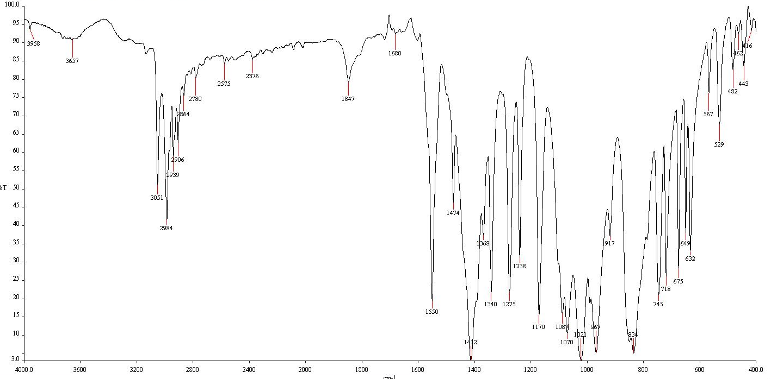
Fig.1 Infrared spectrum of Chlorpyrifos

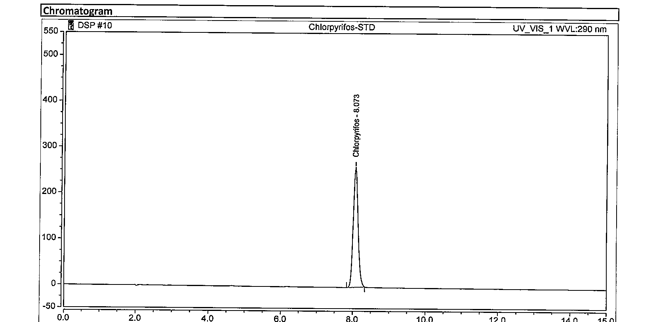
Fig.2 HPLC chromatogram of Chlorpyrifos standard

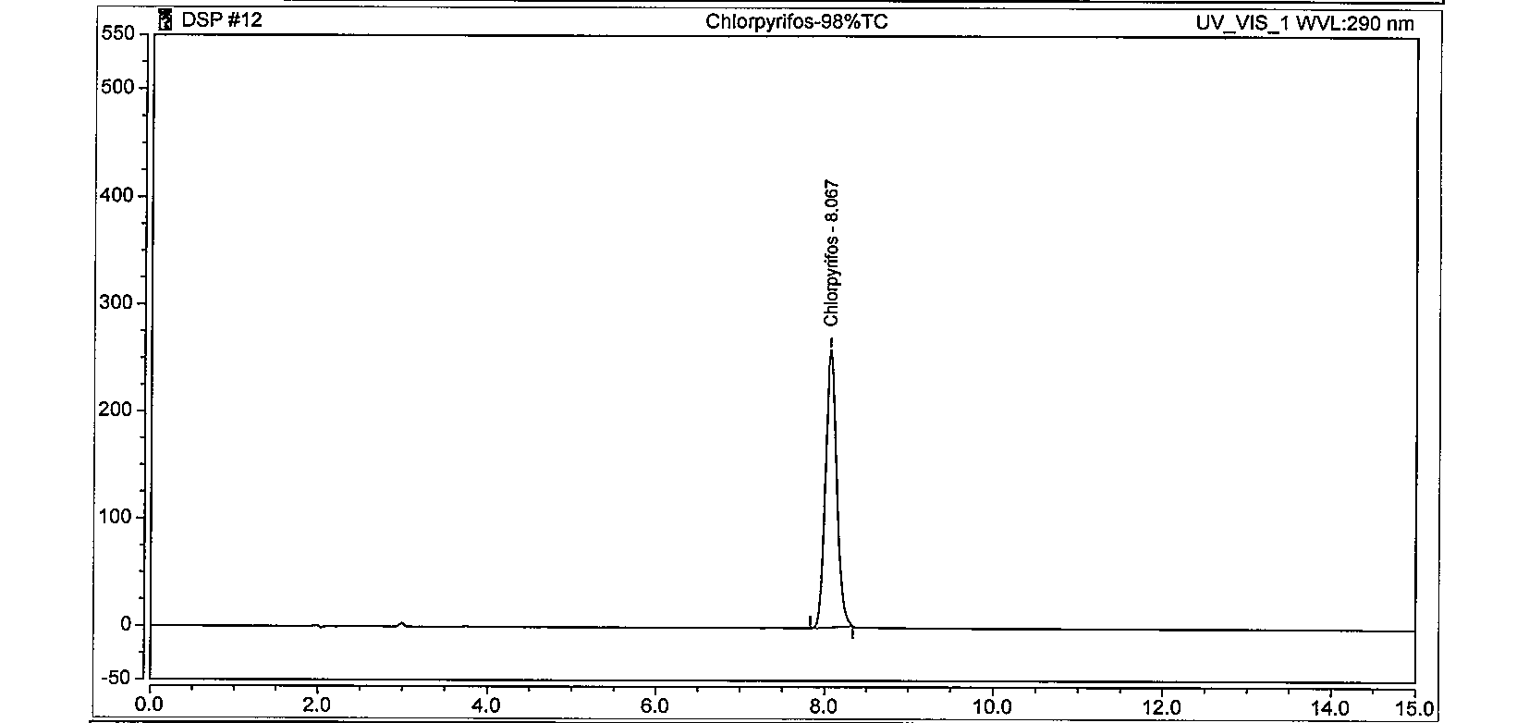
Fig.3 HPLC chromatogram of Chlorpyrifos TC

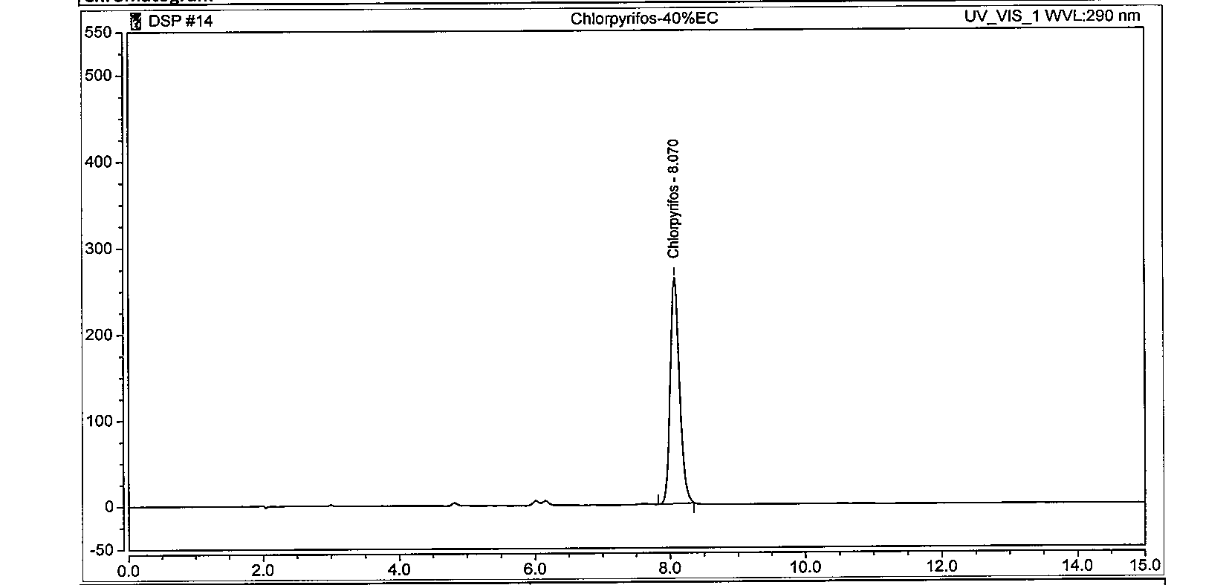
Fig.4 HPLC chromatogram of Chlorpyrifos EC

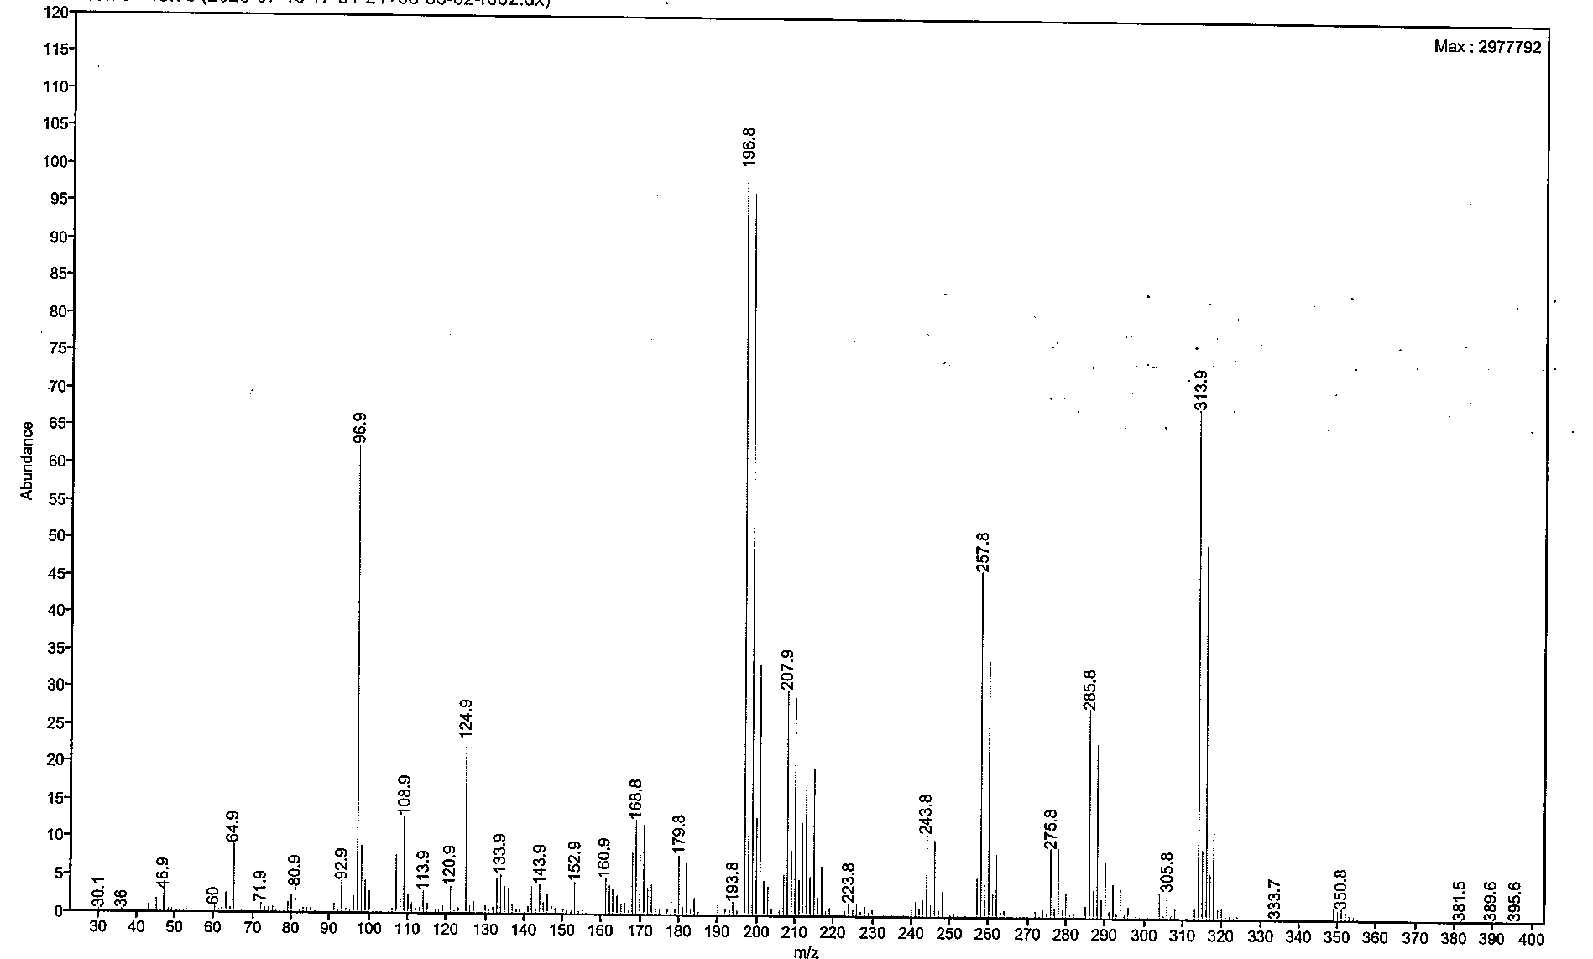
Fig.5 GC-MS spectrum of Chlorpyrifos standard

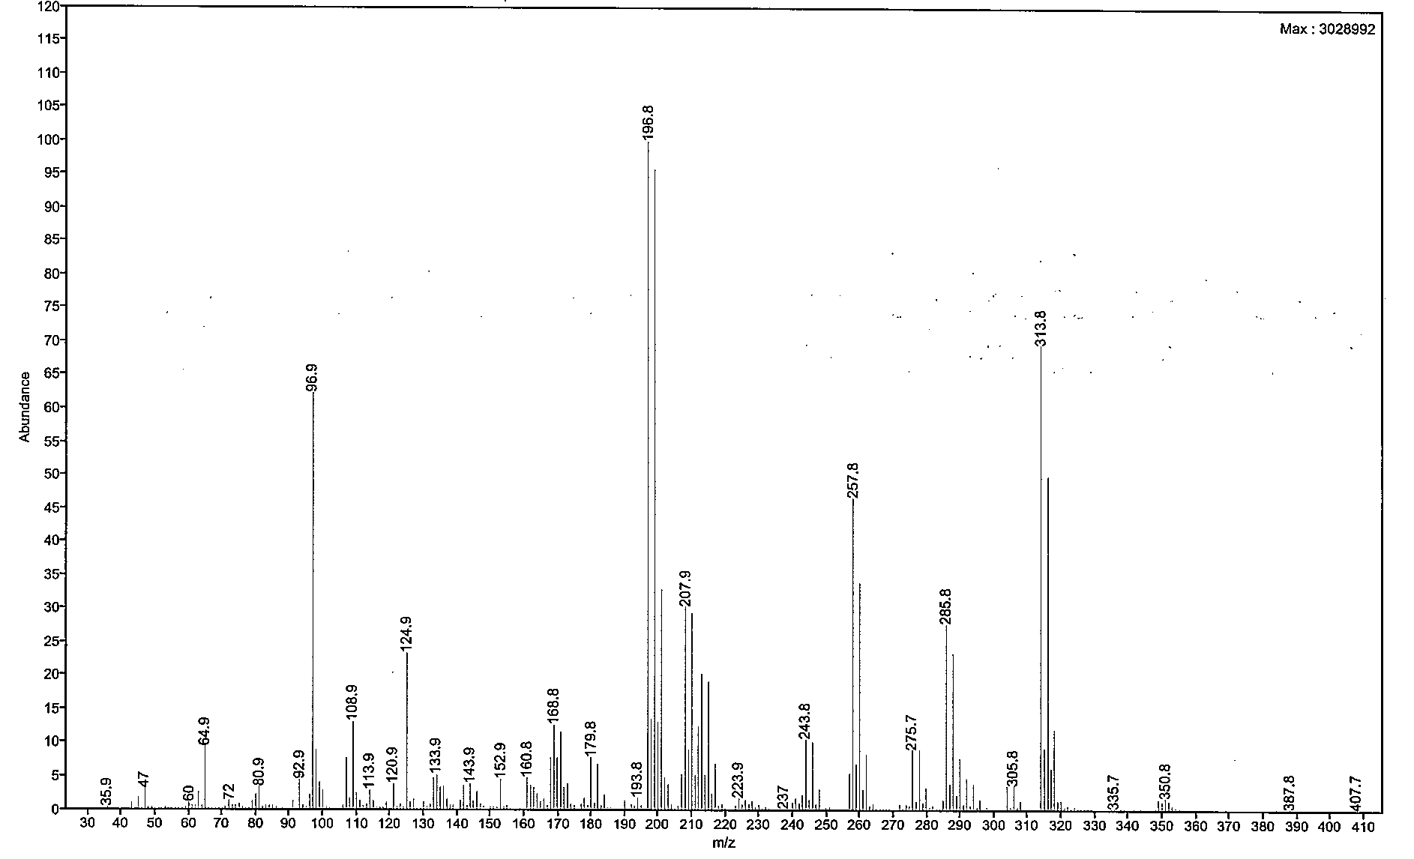

Fig.6 GC-MS spectrum of Chlorpyrifos TC

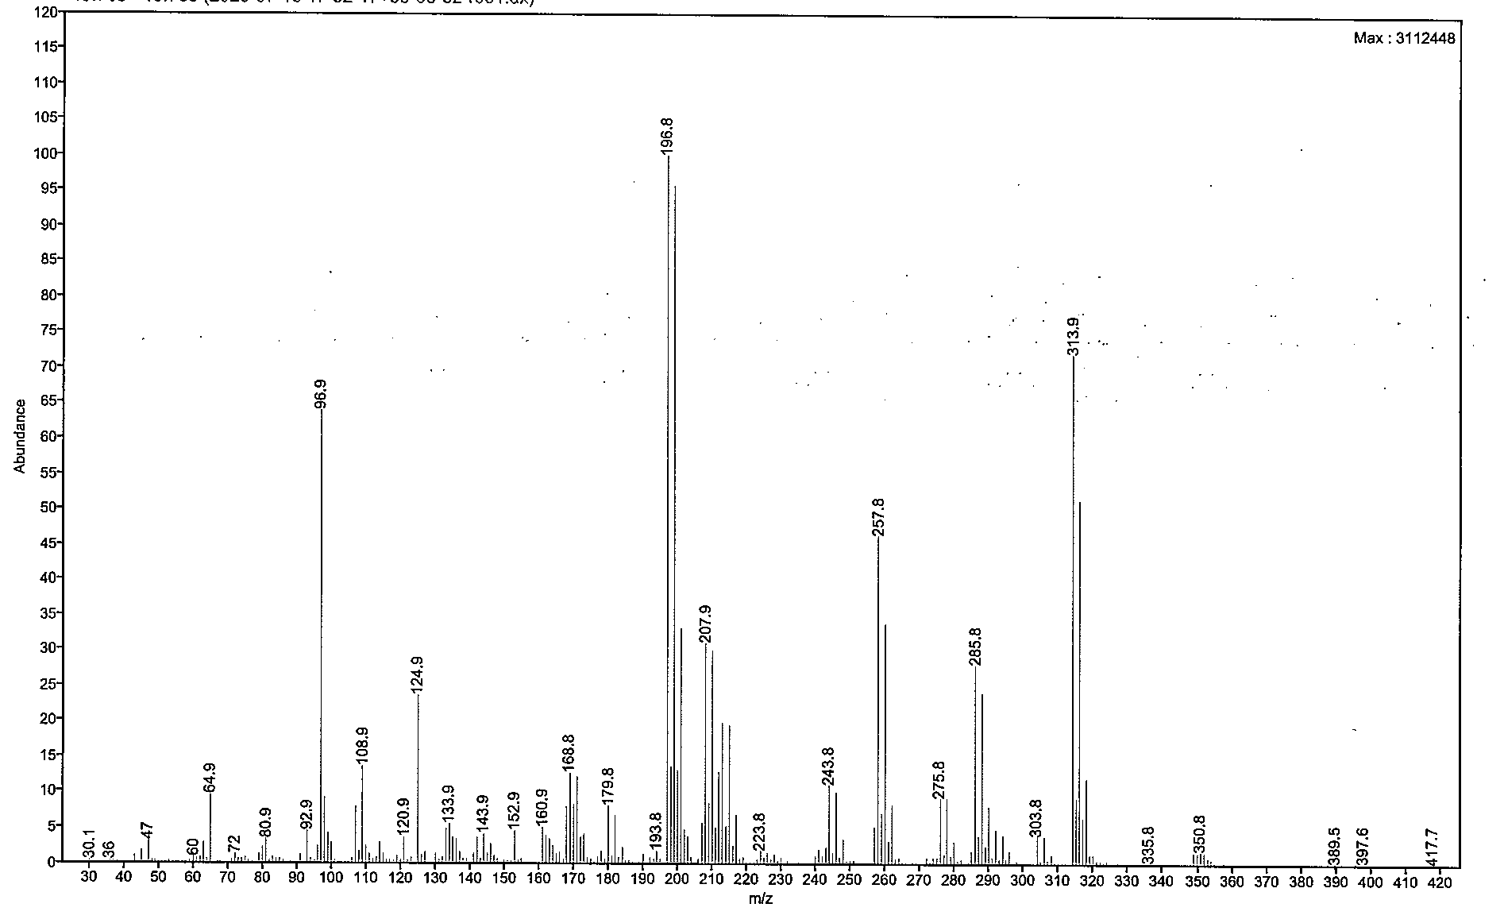
Fig.7 GC-MS spectrum of Chlorpyrifos EC

